Name: Shanne Edralyn N. Erandio Date: 11/27/2025
Course, Year and Section: BSIT 2A

Assessment Laboratory
Bash Scripting + Container Simulation Lab

PART 1: Bash Scripting
Folder Organizer
Write a script that:
- Asks the user for a folder name
- Creates it
- Inside the folder, automatically generates:
  - images/
  - docs/
  - scripts/
- Prints "Folder structure created successfully!"
Use mkdir, echo, and read.
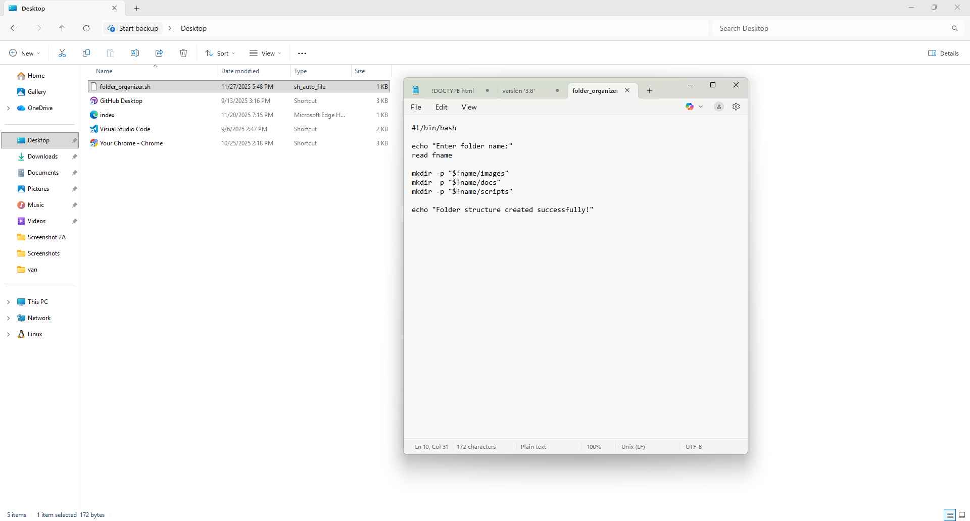
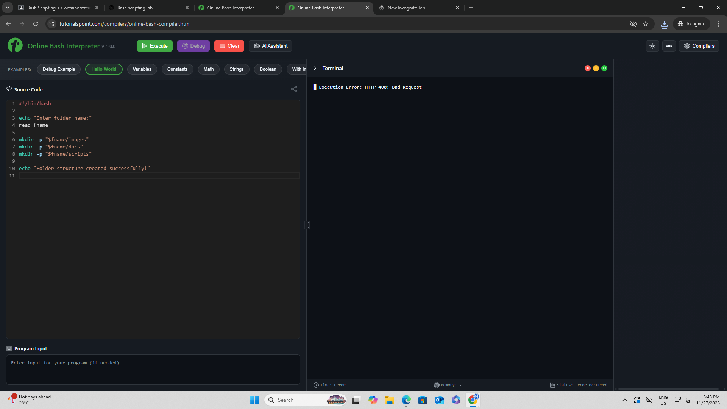

Deliverables (Part 1)
- Bash script (.sh or text)
- Screenshot of script executed in the online IDE
PART 2: Container Simulation Task
Objective:
Show basic understanding of container operations using Play With Docker or Katacoda.

Instructions:
Perform the following in the container simulation environment:
- Pull a Docker image
Type this:
docker pull alpine
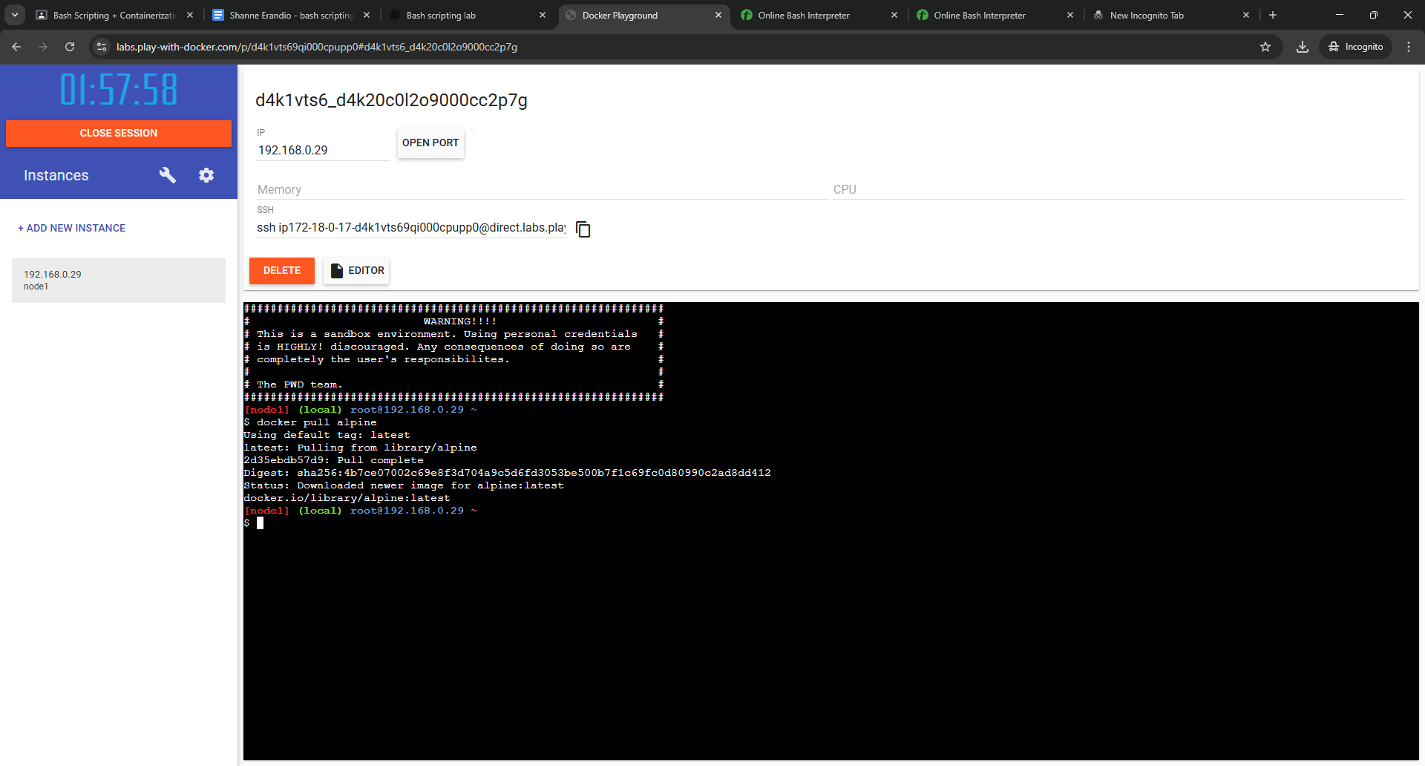
- Run a container interactively
Type this:
docker run -it alpine sh
- You should see this as a prompt: / #
- Seeing that means you are inside the container.
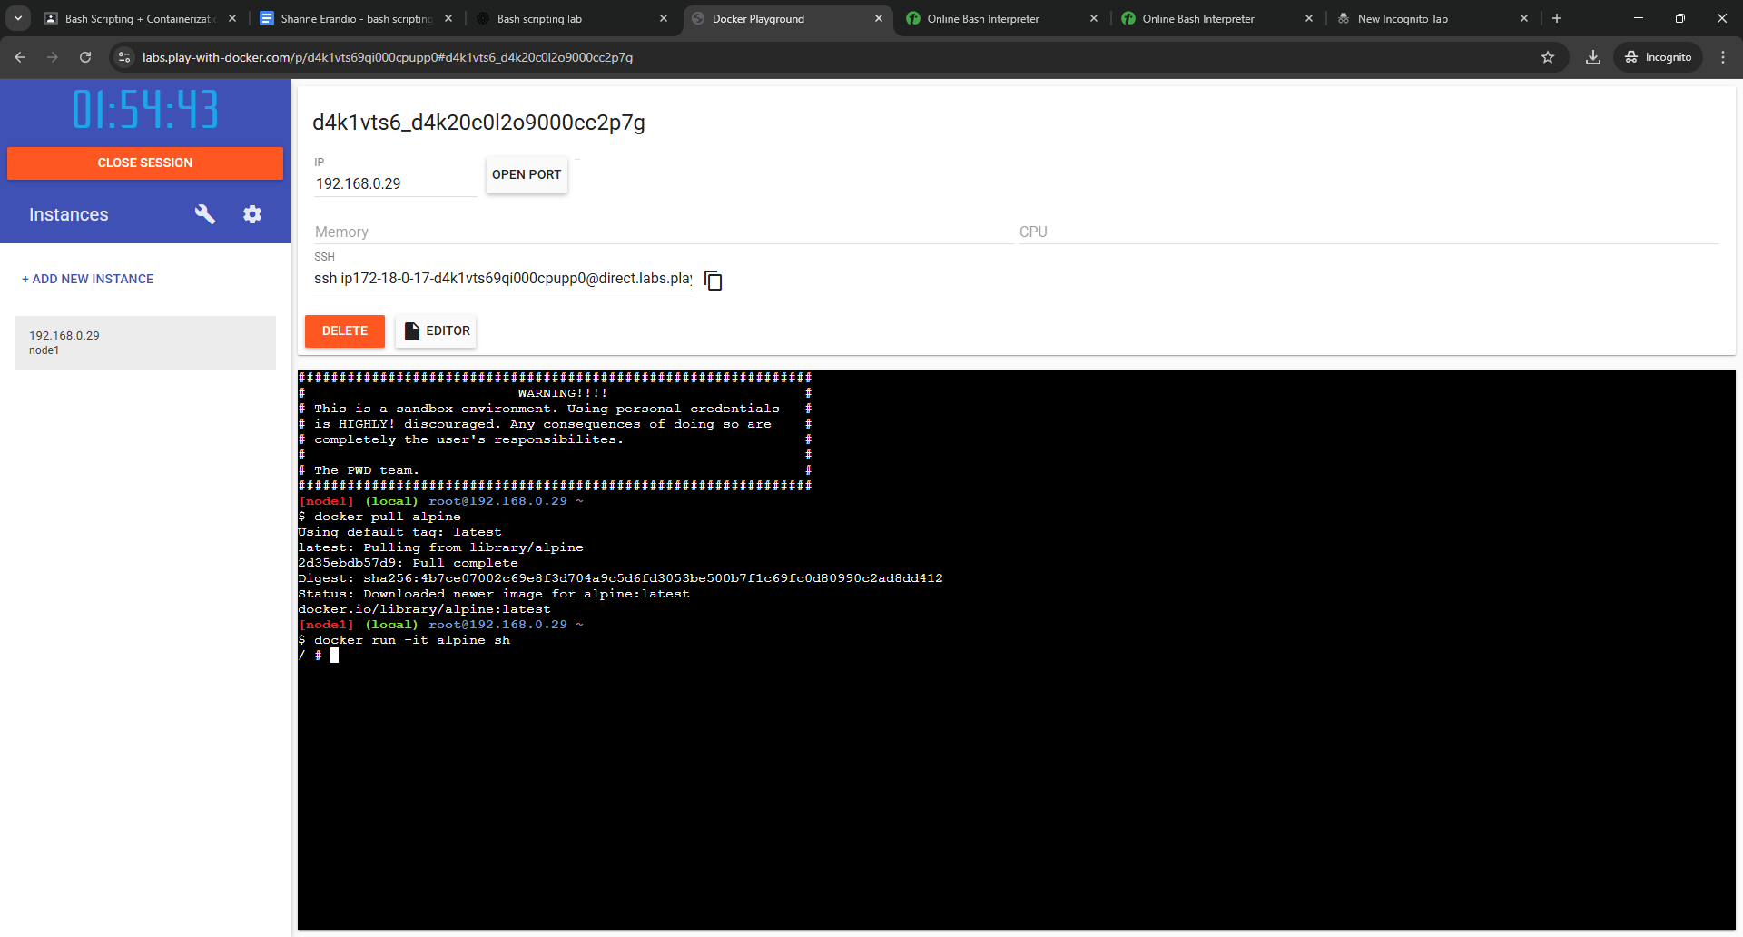
- Inside the container, run:
Type this:
  - pwd
- You should see this as output: /
And then
  - Create a file named hello.txt
Type this:
- echo “Hello from inside the container!” > hello.text
- Verify if it exists by typing: ls
- You should see this: hello.txt
  - Display its contents using cat
Type this:
  - cat hello.txt
  - You should see this: Hello from inside the container!
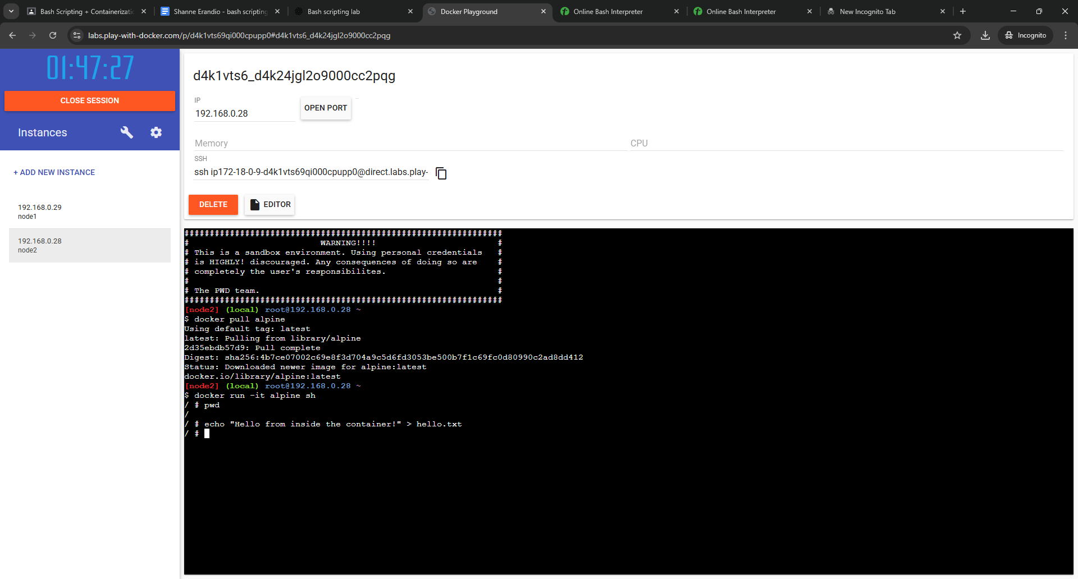

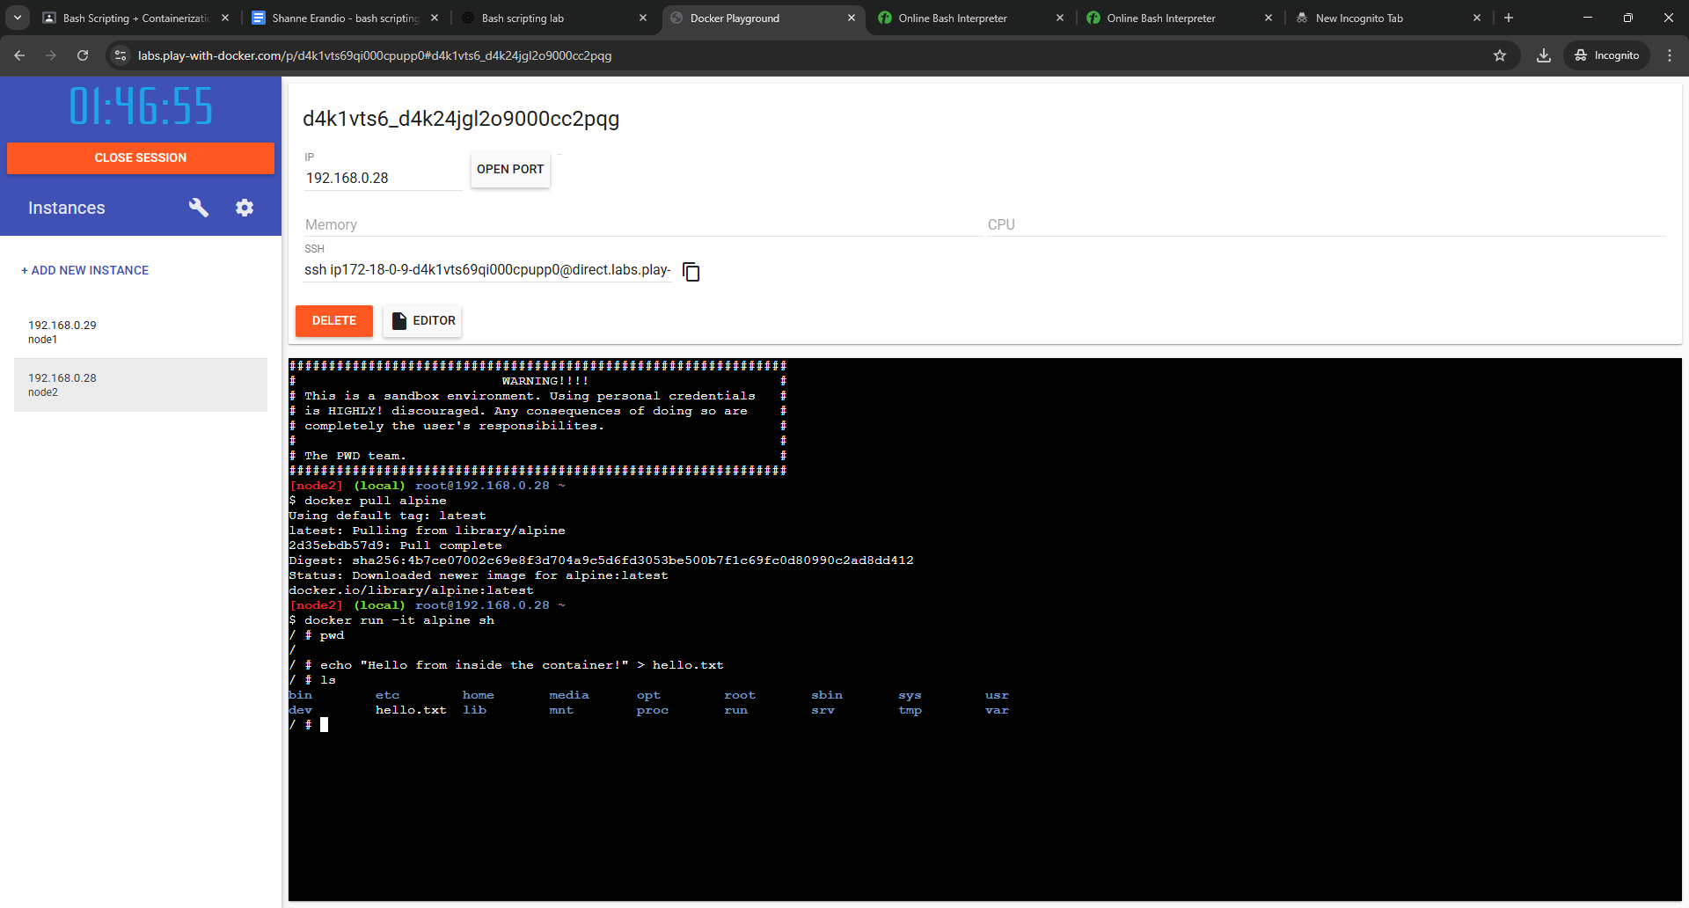
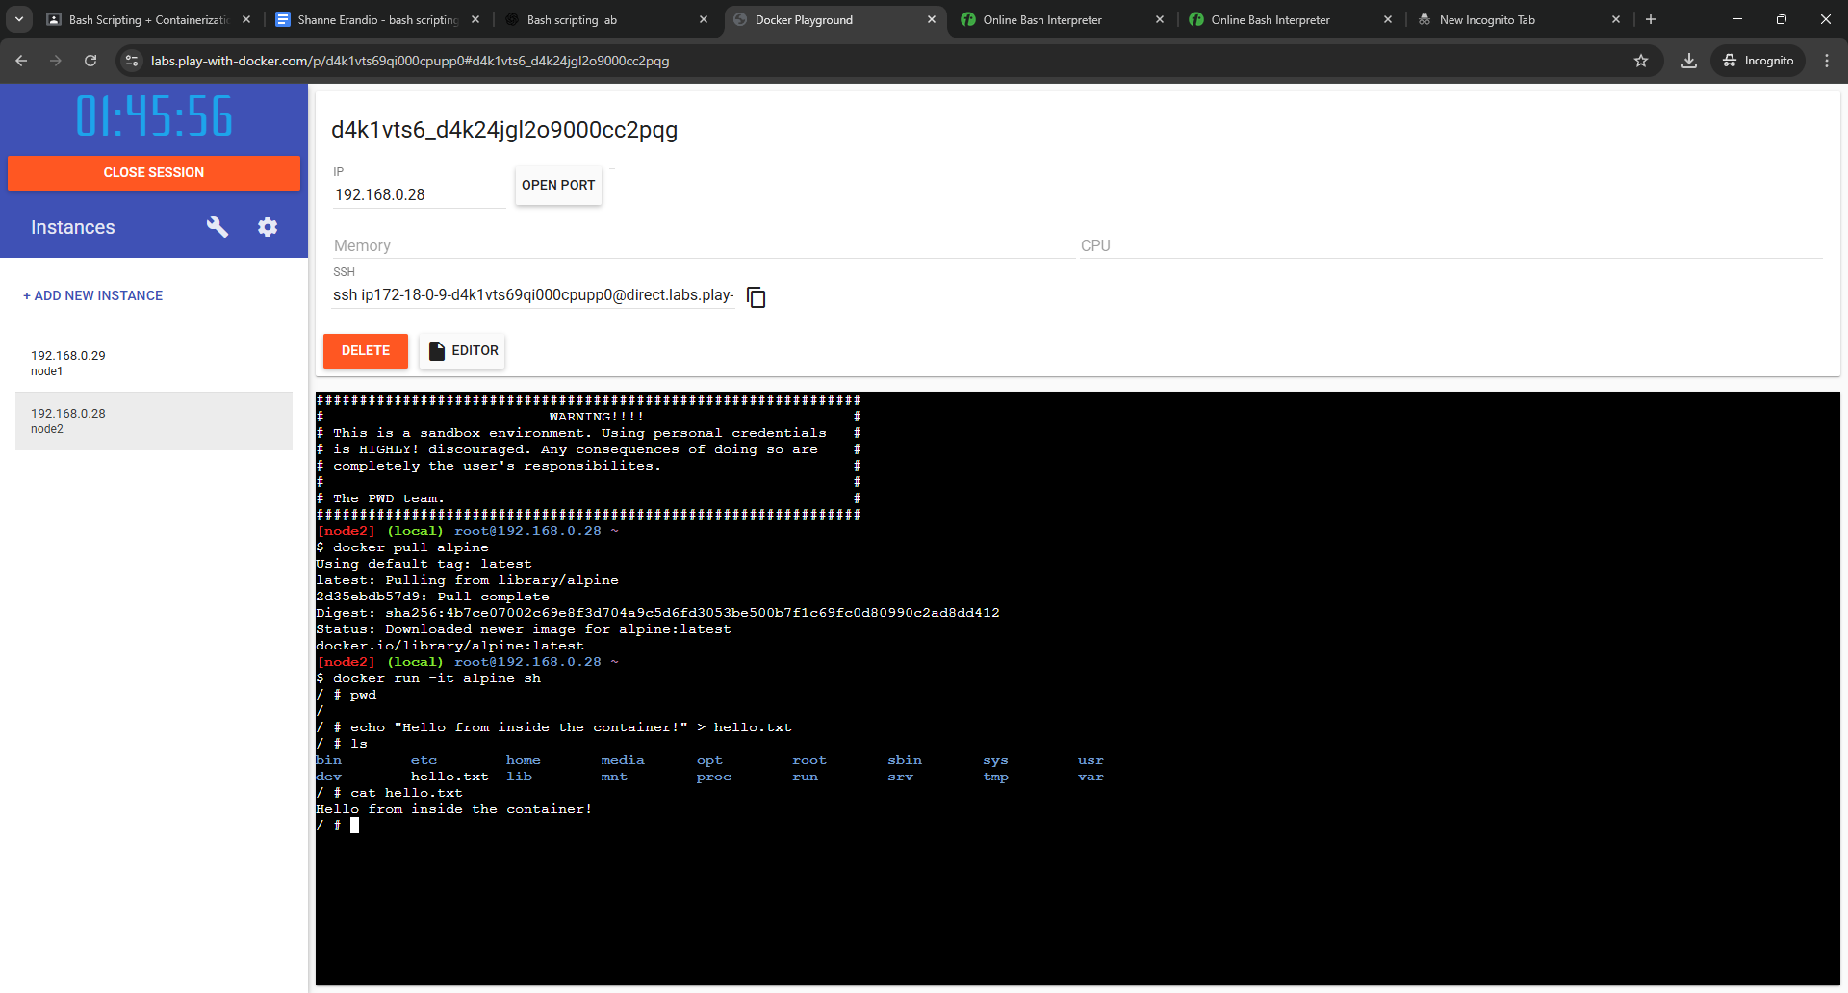
- Exit the container by typing exit
- List all containers
Type this: docker ps -a
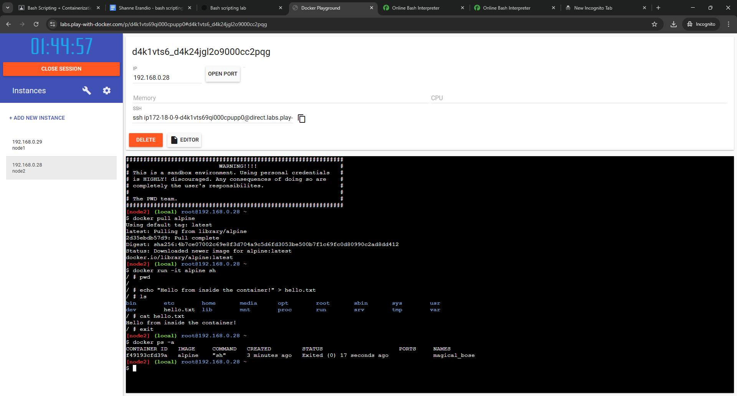
- Remove the container
Type this: docker rm <container_id>
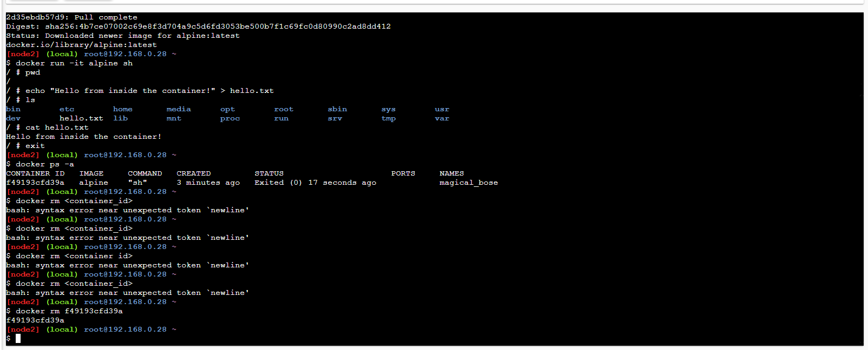

Deliverables (Part 2)
- Screenshot of pulling the image
- Screenshot of running the container
- Screenshot inside the container
- Screenshot of listing and removing the container

REFLECTION
While creating the script, I learned how Bash handles user input and directory creation. Using mkdir -p was helpful because it prevents errors even if folders already exist. Testing the script in the online Bash environment also helped me understand execution permissions and how to run scripts properly using chmod +x and ./filename.sh.
This part taught me how containers work in an isolated environment. I understood how images serve as templates and how containers act as lightweight virtual environments. I also learned the importance of correct syntax, especially when removing containers (using the real container ID instead of placeholder brackets).
The activity helped me become more familiar with container lifecycle commands such as pull, run, inspect, exit, list, and remove.
This laboratory activity strengthened my foundational skills in Bash scripting and container-based workflows. The hands-on practice provided a clearer understanding of automation, file operations, and Docker container management. Overall, this lab improved my confidence in using command-line tools and understanding containerization concepts, which are essential in modern computing environments.

LEARNING OUTCOMES
Students will be able to:
- Write and execute Bash scripts in an online environment
- Use basic Bash constructs: variables, loops, conditionals, input/output
- Demonstrate familiarity with container operations: pull, run, exec, list, remove
- Understand the concept of isolated environments
- Apply automation and command-line skills
Criteria  (20 pts each) | Excellent  (20 pts) | Very Good  (19-17 pts) | Good  (16-14 pts) | Needs Improvement  (13-10 pts) | Poor  (9-0 pts)
1. Code Correctness & Functionality | Program runs flawlessly, meets all case study requirements, produces correct output in all test cases. | Runs with minor issues but overall correct; 1 small error that does not break functionality. | Produces partial correct output; some logic errors but main idea works. | Major errors, incorrect logic, or missing required features; program barely runs. | Does not run, incomplete, or does not match chosen case study.
2. Use of Assembly Concepts (loops, conditionals, segments) | Demonstrates excellent understanding; uses loops/conditionals correctly; segments structured properly. | Proper use of concepts with minor mistakes; logic is mostly correct. | Uses only required structures but with noticeable mistakes or inefficiencies. | Incorrect or missing loops/conditionals; poor segment structure. | No use of required Assembly concepts.
3. Code Organization & Comments | Code is clean, well-organized, clearly commented; comments explain purpose of major instructions. | Well-commented but missing small clarifications; organization still clear. | Some comments present but incomplete or unclear; formatting inconsistent. | Very few comments; messy code structure; hard to read. | No comments; disorganized and difficult to understand.
4. Output Quality (Screenshot & Execution) | Clear screenshot showing correct input and output; format is professional and complete. | Screenshot shows output clearly but missing minor details (e.g., prompt). | Screenshot present but slightly unclear or incomplete. | Screenshot is low-quality, barely readable, or missing key parts. | No screenshot or completely unreadable.
5. Reflection & Understanding | Reflection is insightful, specific, and explains concepts learned and challenges. Shows deep understanding. | Good reflection with clear understanding; missing a bit of detail. | Basic reflection; mentions learning but not specific. | Reflection lacks clarity or detail; shows minimal understanding. | No reflection or irrelevant submission.

